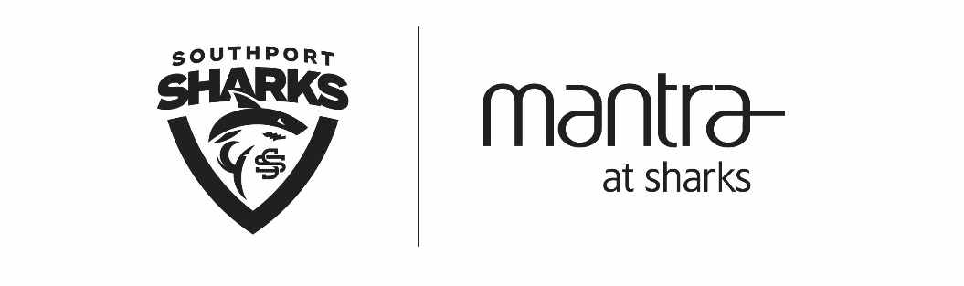
Mantra at Sharks opened in April 2018 featuring 120 rooms, two conference rooms and Aviary Rooftop Bar . It is located in the heart of the Gold Coast Health and Knowledge Precinct, only 10-minutes from Surfers Paradise and five minutes from the stunning Gold Coast Broadwater.
We are currently seeking experienced Room Attendants who are reliable and take pride in their work, to join our Housekeeping team.
The Unique Role…
You will be responsible for maintaining high standards of cleanliness and presentation within guest rooms and surrounding public areas. This will include:
- Cleaning bathrooms, making beds, mopping and vacuuming within the rooms and surrounding public areas
- Assisting with the distribution of linen, changing linen and restocking amenities
- Working with a team who will have a strong Workplace, Health and Safety focus
- Reporting damages and breakages
- Working with a team who will set high grooming standards

The Checklist…
- Previous experience in a 4 to 5-star hotel establishment is desirable
- Have a keen eye for detail
- A friendly and positive attitude
- Enjoy working in a team
- Be self-motivated and be able to work unsupervised
- Previous experience in the use of chemicals and cleaning equipment
- Have knowledge and understanding of basic hygiene requirements and safe working procedures
- The flexibility to work weekends
If you're an energetic housekeeping superstar, with a passion for cleanliness and presentation, apply now by sending your cover letter and resume to hrm@southportsharks.com.au by Wednesday, 30 May 2018.

